UPARC-SSTV-CDR-001

OPEN

CRITICAL DESIGN REVIEW DOCUMENT

SSTV IMAGE TRANSMITTER

Revision 1.00

UPAGRAH AMATEUR RADIO CLUB (VU2URC)

August 2023

Upagrah Amateur Radio Club (VU2URC)

U R Rao Satellite Centre,

Vimanpura Bangalore

Change history

| Version No | Date of Release | Affected Section (Figures, Tables) | Nature of Change  (A, M, D) | Description of change | Remarks |
| --- | --- | --- | --- | --- | --- |
| 1 | 29-July-2023 | All |  | Initial Release |  |
|  |  |  |  |  |  |
|  |  |  |  |  |  |
|  |  |  |  |  |  |

| Prepared by | Dr. Rahul G Waghmare (VU3TJD)  Mohanbabu K (VU3FKA)  Suresh Kumar V (VU3FRC) |  |
| --- | --- | --- |
| Reviewed by | Suman R Valke  President  Upagrah Amateyr Radio Club (VU2URC) |  |
| Approved by | Suman R Valke  President  Upagrah Amateyr Radio Club (VU2URC) |  |

Table of Contents

Chapter 1: Introduction 5

1.1 Overview of Payload 5

1.1.1 Audio 5

1.1.2 Text 5

1.1.3 Images 5

1.2 Purpose 5

1.3 Scope 5

1.4 Definitions, Acronyms and Abbreviations 6

1.5 References 6

1.7 Summary of the Document 6

Chapter 2: Overall Configurations 7

2.1 Mission Requirements 7

2.1.1 Mechanical and Environmental Requirements 7

2.2 Selection Criteria 7

2.3 Hardware configuration of the Payload 7

2.4 Implementation Methodology 8

2.5 PCB and Package Details 8

Chapter 3: Hardware Details of the payload 10

3.1 Circuit Schematic 10

Chapter 4: Electrical Interfaces 13

4.1 Interface with Power 13

4.2 Interface with OBC 13

Chapter 5: Fabrication Procedure 14

5.1 Assembly Sequence 14

5.2 Test Plan 14

5.3 Grounding Scheme 14

Chapter 6: Operation Sequence of the Payload 15

# Chapter 1: Introduction

## 1.1 Overview of Payload

There are various methods of transmitting messages via radio waves such as audio, text, images, and videos. Communication of such messages from satellite to ground forms a vital link for conveying the observations made by satellite payloads to the user of the payload. This document explains one such development where pre-recorded data is being transmitted from space to ground via text, audio, and images. The development further may aid the space community to develop a data transmitter for their satellites.

Proposed payload uses microcontroller as a baseband processor, RF transceiver as RF modulator/demodulator, flash memory as storage device, and R-2R ladder circuit as digital-to-analogue converter. Microcontroller converters information into audio via suitable protocol and will be sent to transceiver at desired sample-rate via R-2R DAC. The RF transceiver is analog FM transceiver which further FM modulates the audio and transmits via antenna.

### 1.1.1 Audio

Pre-recorded audio, such as greeting message, is sampled, quantized, and stored into the flash memory of the payload. These sampled are then rolled out to RF transceiver via R-2R DAC.

### 1.1.2 Text

Text messages, such as greetings or even telemetry information about the payload, are transmitted using AX.25 frame format and AFSK modulation at baseband. These data handling functionalities are implemented by microcontroller. AX.25 (Amateur X.25) is a data link layer protocol originally derived from layer 2 of the X.25 protocol suite and designed for use by amateur radio operators, whereas AFSK modulation is audio frequency shift keying with 1200 Hz and 2200 Hz frequencies used to denote marks and spaces.

### 1.1.3 Images

Pre-recorded images, such as photos depicting certain events or images taken by on-board payload are transmitted to ground using slow scan television (SSTV) mode. An SSTV image is converted into audio by microcontroller using PD120 and Robot72 modes. These modes are known to amateur radio community. Moreover, these signals can be received and decoded by simple setup of VHF/UHF radio and SSTV decoder software in the laptop. In this mode, the pixel intensity of the image is converted into frequency and arranged with appropriate vertical and horizontal sync signals.

## 1.2 Purpose

This document describes the design approach adopted to meet the requirement of the multimode message transmitter to be implemented as an experimental payload for fourth stage of PSLV.

## 1.3 Scope

This document provides brief overview of the project, and the detailed design of the complete payload. The document will aid in the fabrication, wiring, verification, and validation of the payload for POEM platform of PSLV.

## 1.4 Definitions, Acronyms and Abbreviations

APRS – Automatic Packet Reporting System

SSTV – Slow Scan Tele-Vision

AX.25 – Amateur X.25 Protocol

VHF – Very high frequency (Here, 144 MHz to 146 MHz enabled for amateur radio operation)

UHF – Ultra high frequency (Here, 434 MHz to 438 MHz enabled for amateur radio operation)

DAC – Digital to Analogue Converter

RF – Radio Frequency

FM – Frequency Modulation

PSLV - polar satellite launch vehicle

POEM - PSLV orbital experimental module

## 1.5 References

1. Martin Bruchanov (OK2MNM), “Image Communication on Short Waves”, <https://www.sstv-handbook.com/>, downloaded on 30-07-2023.

2. Datasheet of STM32F103CBT6 Micrcontroller. <https://www.st.com/en/microcontrollers-microprocessors/stm32f103cb.html>, downloaded on 30-07-2023

3. The APRS Working Group, “APRS101: APRS Reference Protocol”, <http://www.aprs.org/doc/APRS101.PDF>, downloaded on 30-07-2023

4. Datasheet of SA868 Module, <https://www.nicerf.com/item/2w-embedded-walkie-talkie-module-sa868> downloaded on 30-07-2023

## 1.7 Summary of the Document

Chapter 2 provides overall configuration of the payload. Chapter 3 provides circuit schematic details along with component list and PCB details. Chapter 4 contains information regarding required interfaces of the payload with other subsystems. Chapter 5 provides the detailed guidelines for fabrication, testing and evaluation of the payload. Chapter 6 provides various modes and operations of the payload.

# Chapter 2: Overall Configurations

## 2.1 Mission Requirements

Multimode message transmitter payload shall store the messages of audio, text, and image format into flash memory, shall generate encoded audio as per standard baseband modulation formats, and shall transmit them over RF link. Details of the mission requirements are summarized as follows:

| **Parameters** | | **Units** | **Values** |
| --- | --- | --- | --- |
| Frequency of operation | | MHz | 145.970 (Tentative, subject to EMI requirements of POEM) |
| Transmit power | | W | 2 |
| FM Frequency deviation | | Hz | 2500 |
| RF Modulation | |  | FM |
| Message types | |  | Audio, Text, Image |
| Baseband Modulation | Audio |  | None, sampled and quantized audio |
| Text |  | AFSK modulation, AX.25 Frame Format |
| Image |  | SSTV PD120 and Robot72 Modes |

### 2.1.1 ETLS Requirements

As per PSLV ETLS document requirements

## 2.2 Selection Criteria

To meet the mission requirements, STM32F103CBT6 microcontroller is chosen as a baseband processor which provides adequate resources for I/O interfaces with other modules, has adequate storage for the program code and RAM memory for storing the intermediate variables. SA868 provides a holistic RF solution with -110 dBm of sensitivity and 2W of RF output. These modules are powered by isolated DC-DC converter (LM25184EVM-S12).

## 2.3 Hardware configuration of the Payload

Figure 2.1 shows the block schematic of the payload and highlights major parts of the hardware of the payload. Power module, implemented on separate PCB, generated secondary voltage levels for various components of the payload while maintaining isolation between primary and secondary grounds. Voltage and current sensors used in the power module provides power supply status which will be subsequently transmitted to ground via APRS packets as a text data.

Signal Processing software

VHF FM Transceiver

ADC

DAC

512Mb Flash

Memory

Microcontroller

Antenna

Half Duplex

Vcc-1

Vcc-2

Vcc-3

Audio Out

Audio In

UART &TTL interface to transceiver for control and status monitoring

Temperature sensor, Voltage/Current Sensor

Electric Power

Management

Vcc-1

Vcc-2

Vcc-3

28V to 42V



Figure 2.1: Block Diagram of the Payload

Flash memory store the pre-recorded audio, text, and images. These messages are read by microcontroller and then converted into audio using suitable protocol. Converted audio is in digital format and needs to be converted into analog format before giving it to the transceiver. R-2R ladder DAC will convert digital bits into analog baseband waveform. RF transceiver, FM modulates the incoming signal over VHF band and generates 2W RF signal which is fed to the antenna.

In addition, RF signals received by antenna is demodulated by RF transceiver and baseband signals are generated. Baseband processing of demodulated signal is handled by the microcontroller. This enables the reception of the tele-command from the ground in APRS packet format. APRS packet will be decoded and appropriate mode will be selected for payload operation (sending acknowledgement cards (QSL cards), repeating the message (as APRS digipeater) and many more).

## 2.4 Implementation Methodology

Multimode messages transmitter payload is realized in package with two decks side-by-side. Deck-1 contains PCB of standard PC-104 dimension and deck-2 with PCB of 56mmx36mm, and overall dimension of the package is 100mmx150mmx40mm. Overall weight of the package is around 500gm. It shares the interface with power system of POEM. And interface with antenna is through on-card SMA connector.

| **Card No.** | **Description** | **Interfaces** |
| --- | --- | --- |
| UPARC-SSTV-001 | DC-DC card | Power and OBC of PS4 of PSLV |
| UPARC-SSTV-002 | Transceiver card | Power: UPARC-SSTV-001  RF: Antenna |

## 2.5 PCB and Package Details

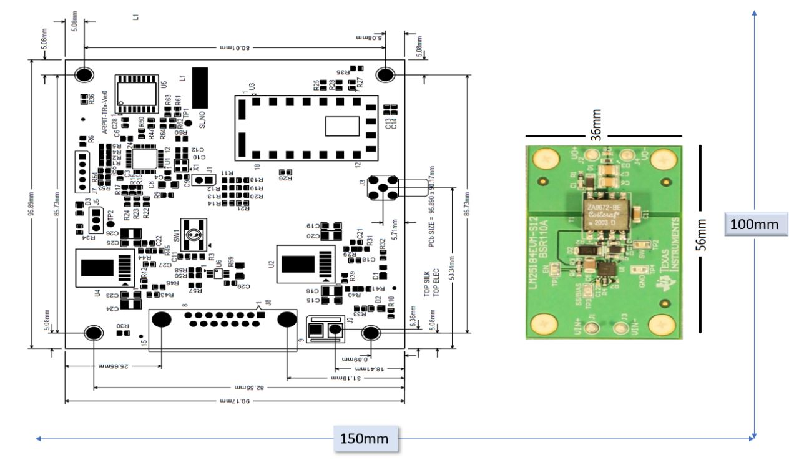Multimode message transmitter payload is realized as a stack of two deck containing DC-DC converter and processor electronics. Mechanical dimensions of the cards and the housing are shown in the figure 2.2.

Figure 2.2: Mechanical dimensions of the Payload

# Chapter 3: Hardware Details of the payload

## 3.1 Circuit Schematic

The circuit schematic of the payload is shown in figures 3.1 to 3.6.

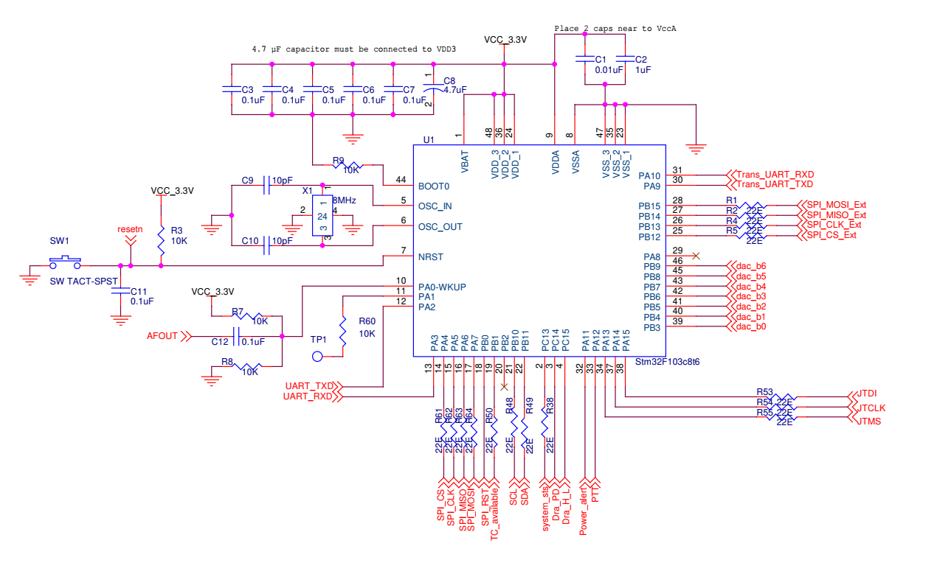

Figure 3.1: Baseband processor of the payload using STM32F103CBT6

The task of the baseband processor is to interface with memory, RF transceiver and power sensor to initialize the whole payload and perform the baseband data handling operations. STM32F103CBT6 microcontroller is clocked using 8 MHz crystal oscillator which is further multiplied by 9 internally to generate 72 MHz system clock. It also interfaces with R-2R DAC via parallel port. Figure 3.1 shows the schematic of the configuration of microcontroller as a baseband processor.

Raw bus supply of 28V-42V is first down converted to 12V using isolated DC-DC converter. Further more 12V is down converted to 3.3V and 4V using LMZ14202 and details are as shown in the blow figures.

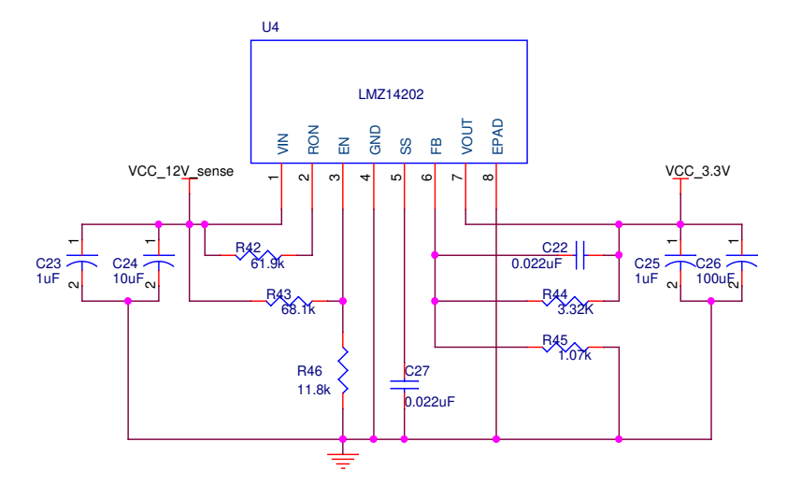

Figure 3.2: DC-DC stepdown converter for microcontroller power supply

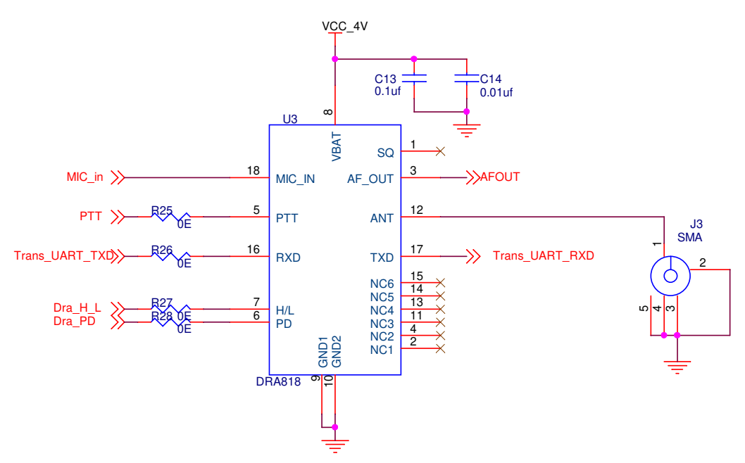

Figure 3.3: Configuration of RF transceiver

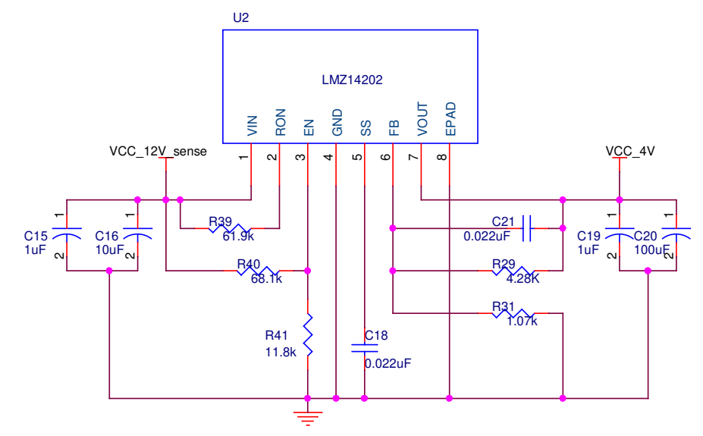

Figure 3.4: DC-DC stepdown converter for RF Transceiver power supply

RF front end of the payload is being handled by FM transceiver (SA868v) to receive APRS packets and transmit the baseband modulated audio signals. The FM transceiver, SA868v, operates on frequency range from 134 MHz to 174 MHz. It can be configured for a single channel of either 12.5 KHz or 25 KHz with maximum frequency deviation of 2.5 KHz. The FM transceiver needs to be configured over UART interface and the output power can be controlled using level command either in High (2 W) or Low (0.25 W) mode. The transceiver can be kept in sleep mode by providing a level command. These functionalities are implemented by microcontroller. Interface between FM transceiver and antenna is provided via SMA connector. Figure 3.3 shows the schematic of the FM transceiver configuration. The power supply schematic to generated 4 V supply from satellite raw supply is shown in figure 3.4.

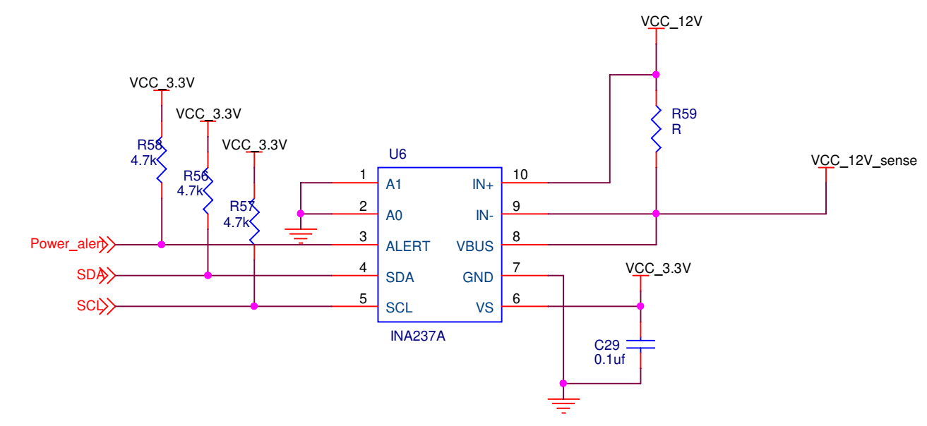

Figure 3.5: Power sense module

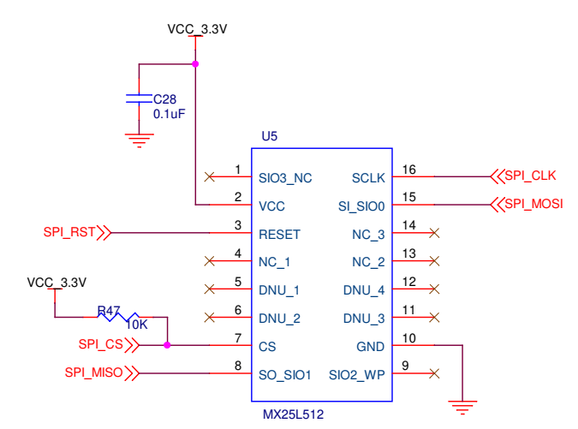

Figure 3.6: Flash Memory module

Memory and power sensor module shown in the figure 3.5 and 3.6 are used to store the message and to sense the status of power supply respectively. Power sense module is interfaced with microcontroller via I2C interface whereas memory module is interfaces with microcontroller over SPI protocol. It is to be noted that the flash memory will be programmed to store the data before the T&E of the payload and shall not be written subsequently.

Arrangement is provided as an indicator for secondary supply status via separate LEDs on the card. These LEDs can be made during the final T&E of the payload and in the flight model of the paylaod.

# Chapter 4: Electrical Interfaces

Multimode message transmitter payload shares electrical interface with POWER and OBC of the PS4 stage of the PSLV.

## 4.1 Interface with Power

The payload interfaces with power subsystem to receive raw bus supply. Secondary voltage levels of 3.3V and 4V required for microcontroller and RF transceiver are further derived from raw bus via DC-DC converters and switching step-down regulators. Figure 4.1 shows the power interface scheme of the payload.



Figure 4.1: Interface with Power

## 4.2 Interface with OBC

The payload interfaces with OBC to receive ON/OFF command. Figure 4.2 shows the interface details between OBC and payload.



Figure 4.2: Interface with OBC of PSLV

# Chapter 5: Fabrication Procedure

## 5.1 Assembly Sequence

Following guidelines are identified to enable safe assembly and testing of components on payload cards.

1. Mounting of components using reflow soldering method.

2. Programming of microcontroller with configuration code using programming header for writing the data into the flash memory.

3. Programming the microcontroller for flight code using programming header.

## 5.2 Test Plan

Following steps are identified towards testing and evaluation of the payload.

1. Initial bench test to confirm the reception of all the forms of messages using standard ground

station setup.

2. 240 hours of burn-in of the assembled digipeater card to up-screen the non-standard components

3. Environmental testing such as vibration and thermovacuum testing.

4. Final function testing using standard ground station setup.

## 5.3 Grounding Scheme

Primary and secondary grounds are isolated at the DC-DC converter level, however secondary grounds are connected to payload chassis and brought out at the AIT connectors.

# Chapter 6: Antenna Assembly

1. Inverted F antenna
2. Mono Pole antenna

# Chapter 7: Operation Sequence of the Payload

To be discussed and finalized

1. Primary Functions:
   1. Pre-Recorded image transmission using SSTV
   2. Pre-Recorded Audio message transmission
   3. Telemetry (House Keeping/ Health Parameters) transmission (AX25 packet) using AFSK/BPSK
   4. Morse Code (CW) Beacon
   5. QSL card (Black & White Image) acknowledgement for successful user uplink
   6. Telecommand based mode selection for primary functions 1,2 & 5
2. Secondary Functions (optional):
   1. Short message service (SMS) store and forward
   2. Digipeater